INTRODUCTION

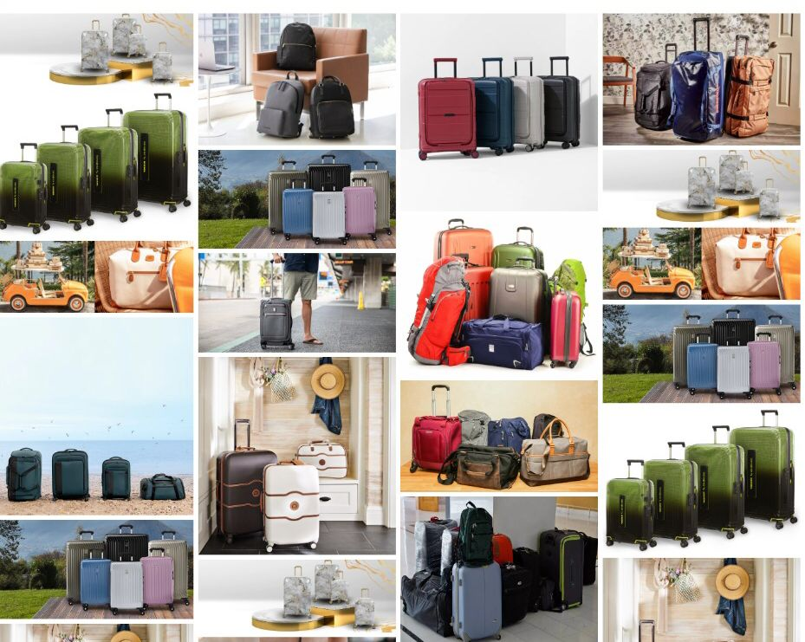Bronx luggage has been in business for 27 years with over 60 years of experience. The owners and management of bronx luggage will match you with one of the many brands that will best fill your luggage needs.  We are an authorized briggs & riley repair center and the only authorized dealer in the festival marketplace.

***TABLE OF CONTENT***

Site Map…………………………………..03

Home…………………………………..04

Gallery……..…………………...…….. 05

Brands…………………..….. 08

Categories..………...……….. 09

About Us.…………..……………….... 10

Contact Us………………...………...……… 11

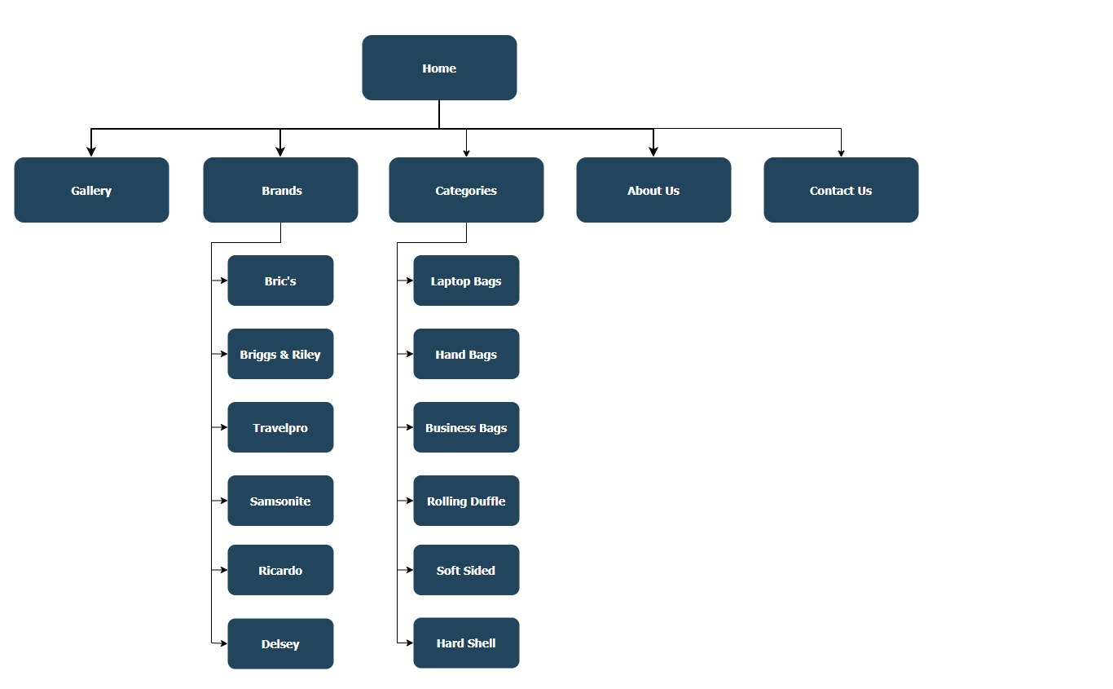**SITE MAP**

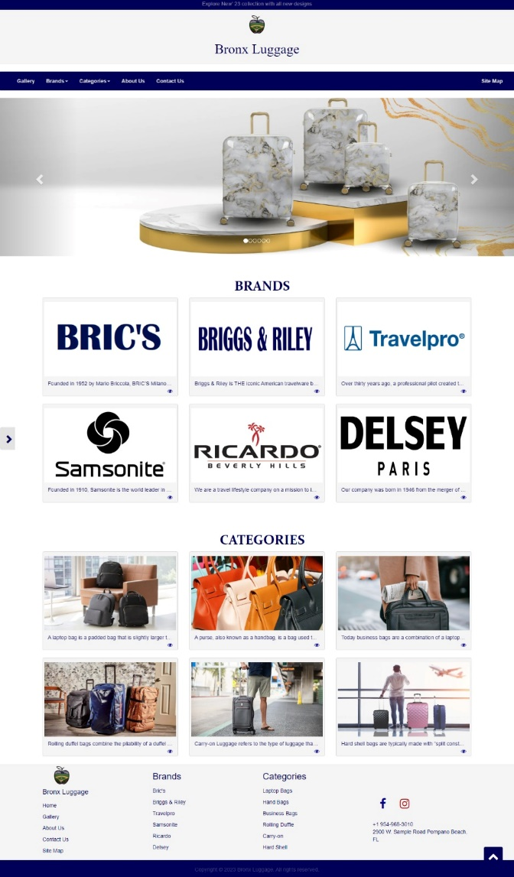**HOME**

A home page is the primary web page that a visitor will view when they navigate to a website via a search engine, and it may also function as a landing page to attract visitors. In some cases, the home page is a site directory, particularly when a website has multiple home pages.

**GALLERY**

Gallery is a page which contain large numbers of media content almost always, images with little or no supporting text.

**BRANDS**

**Bronx Luggage**

 offers some very high quality

but affordable luggage collections including you best source in Broward for a wide range of luggage from Briggs and Riley, Travelpro, Samsonite, Ricardo Beverly Hills, Delsey Paris and many others

**CATEGORIES**

Our rolling suitcase, duffle bags are the ultimate duo for any traveler. Wherever Your Travels Take You, Our Gear Will Help You Get There.

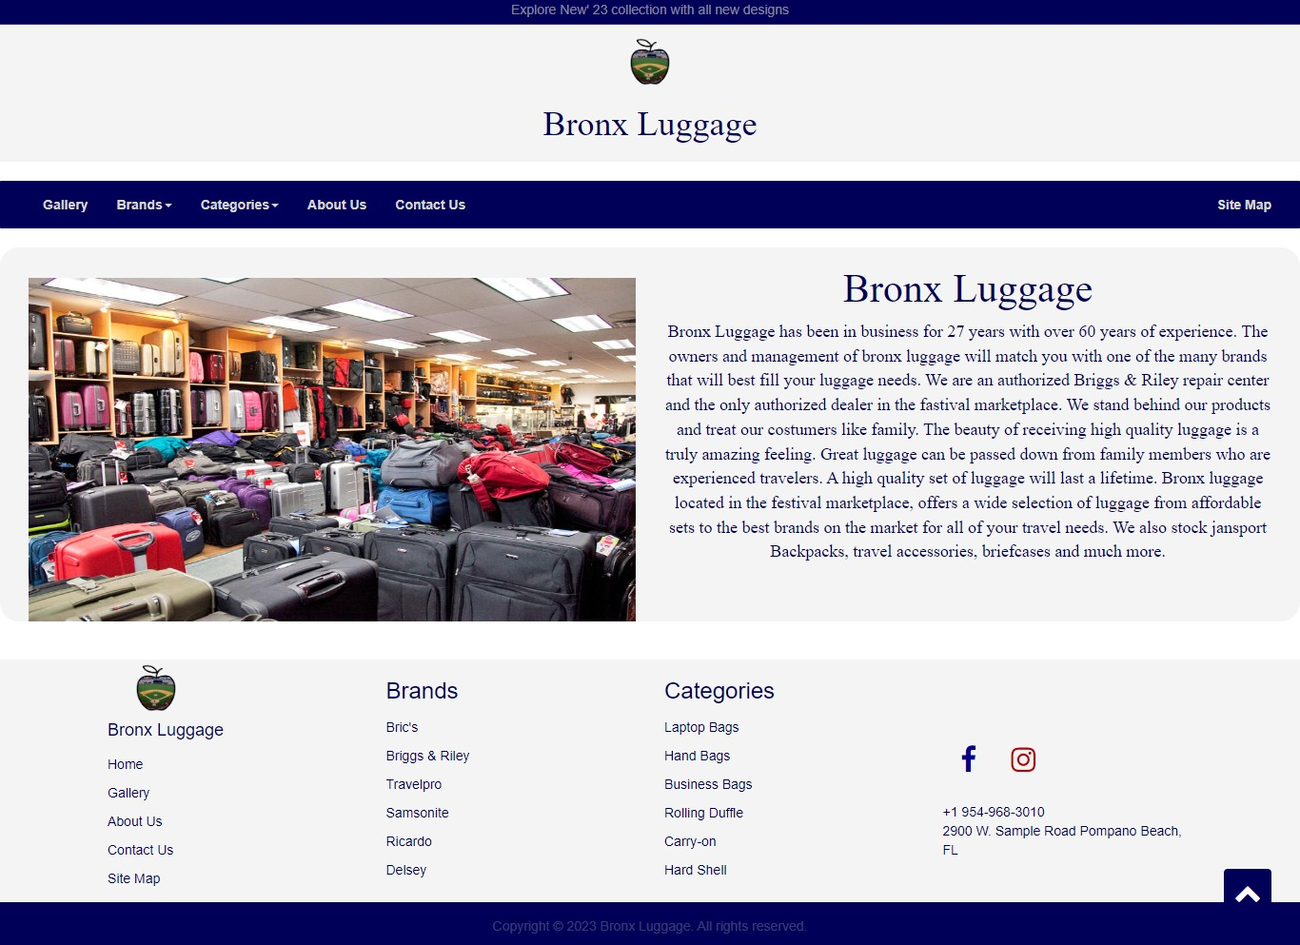**ABOUT US**

The primary purpose of an about us page is to inform the reader about the company and its operations. This is a straightforward goal that nearly all businesses have to fulfill in some fashion or another. However, there are other reasons why about us pages are common fixtures on business websites.

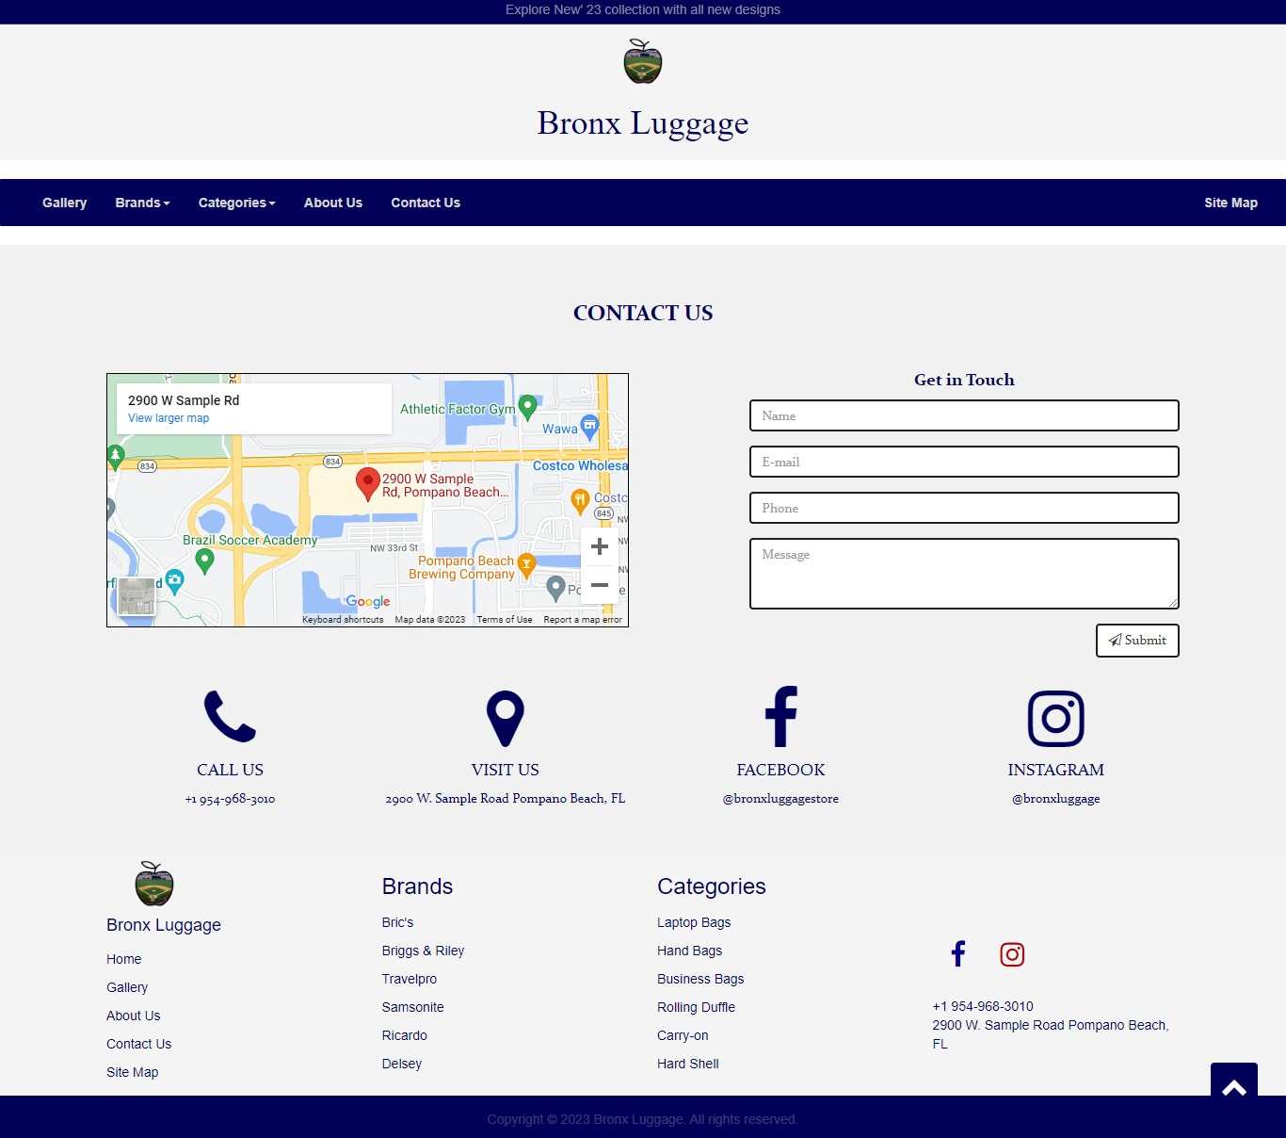**CONTACT US**

A Contact Us page is essential to building a brand's website as it allows visitors to contact you easily without leaving their browser. They also give you the opportunity to capture leads and improve customer service. Generally, visitors can also leave feedback or ask questions through these channels.